## **Test Report**

****Test Report**** is a document which contains a summary of all test activities and final test results of a testing project. Test report is an assessment of how well the[Testing](https://www.guru99.com/software-testing.html)is performed. Based on the test report, stakeholders can evaluate the quality of the tested product and make a decision on the software release.

For example, if the test report informs that there are many defects remaining in the product, stakeholders can delay the release until all the defects are fixed.

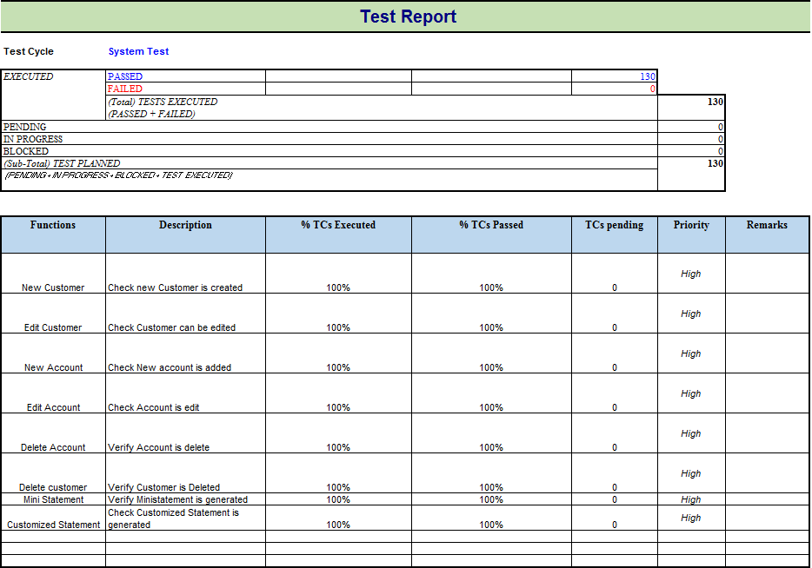

The typical benefits of a test report include:

## **What does a test report contain?**

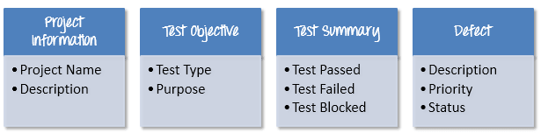

### **Project Information**

All information of the project such as the project name, product name, and version should be described in the test report. For example, the information of Guru99Bank project will be as follows

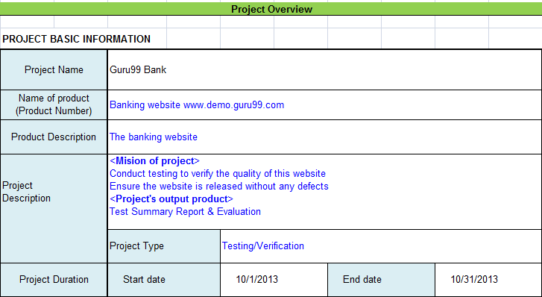

### **Test Objective**

As mentioned in [Test Planning](https://www.guru99.com/what-everybody-ought-to-know-about-test-planing.html) tutorial, Test Report should include the objective of each round of testing, such as Unit Test, Performance Test, System Test …Etc.

### **Test Summary**

This section includes the summary of testing activity in general. Information detailed here includes

* The number of test cases executed
* The numbers of test cases pass
* The numbers of test cases fail
* Pass percentage
* Fail percentage
* Comments

This information should be displayed ****visually**** by using ****color indicator****, ****graph, and highlighted table****.

**[Take a look at Test Report of the website Guru99 Bank to know more detail about Test report](https://images/TestManagement/Guru Test Report.xlsx)**

### **Defect**

One of the most important information in Test Report is defect. The report should contain following information

* Total number of bugs
* Status of bugs (open, closed, responding)
* Number of bugs open, resolved, closed
* Breakdown by severity and priority

Like test summary, you can include some simple metrics like[Defect](https://www.guru99.com/defect-management-process.html)density, % of fixed defects.

The project team sent you the Defect information as following

* Defect density is 20 defects/1000 lines of code average
* 90% defects fixed in total
* The detail of the bugs are described in this Defect tracker [here](https://docs.google.com/spreadsheet/ccc?key=0Au2ff2t4xXuGdFZlek9zbHhUcnVleHVyOVp0VmFHMmc&usp=drive_web" \l "gid=0)

You can represent the data as following graph

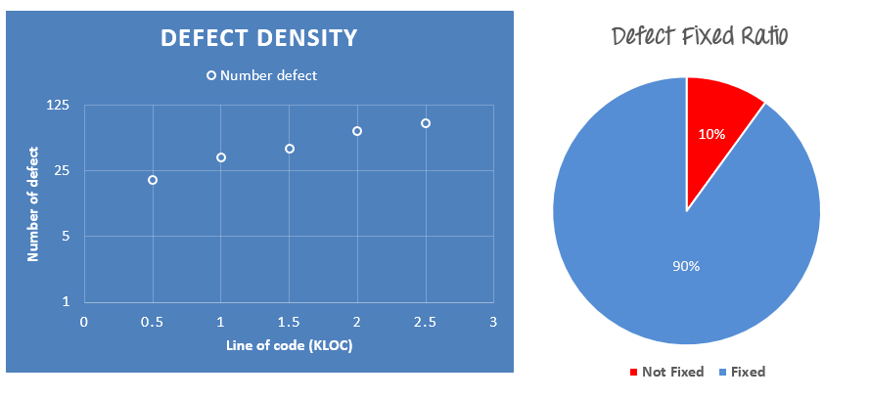

## **Tips to write a good test report**

Test report is a ****communication**** tool between the Test Manager and the stakeholder. Through the test report, the stakeholder can ****understand**** the project situation, the quality of product and other things.

The following scenario shows you why we need a good Test Report

You co-operate with outsourcing company, its tester after having performed [Performance Testing](https://www.guru99.com/performance-testing.html) of the website Guru99 Bank, sends you a test report like this

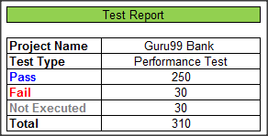

The information of that report is too ****abstract****. It does not have any detailed information. The stakeholder who will read it might be slightly ****puzzled**** when they get it. They might ask or have following sets of questions: –

* Why did they not execute 30 TCs that remains
* What are these failed Test Cases
* Doesn’t have any bugs description

To solve that problem, a good Test Report should be:

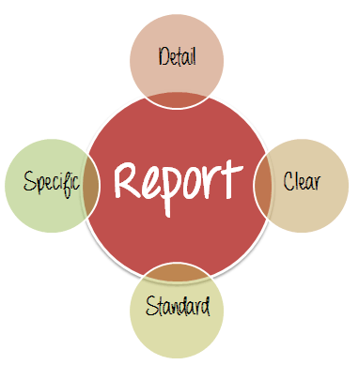

* ****Detail****: You should provide a detailed description of the testing activity, show which testing you have performed. Do not put the abstract information into the report, because the reader will not understand what you said.
* ****Clear:****All information in the test report should be ****short**** and ****clearly**** understandable.
* ****Standard:****The Test Report should follow the ****standard**** template. It is easy for stakeholder to review and ensure the ****consistency**** between test reports in many projects.
* ****Specific:****Do not write an essay about the project activity. Describe and summarize the test result specification and focus on the main point.

For example, to correct the above Test Report, the tester should provide more information such as:

* Project information
* Test cycle: (System Test, Integration Test…etc.)
* Which functions have already tested (% TCs executed, % TCs passed or fail…)
* Defect report (Defect description, Priority or status…)